Instruction for Use

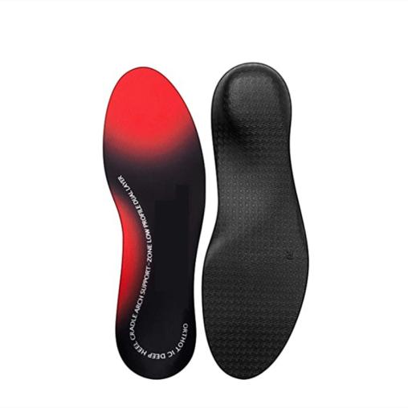

Common Examples of Use
Adjust the lower limb biomechanical lines, improve gait, reduce joint pressure, and minimize sports injuries by supporting the arch of the foot and changing the distribution of plantar pressure.
Effectively intervenes in foot problems such as arch flattening, high arch foot and hallux valgus.
Relieve foot pain caused by arthritis, nerve damage, musculoskeletal disorders, etc.

WARNING:
This product should be given by an treating doctor and applied by a professional. Application should be done with great care to ensure correct fit and efficiency of the brace. For hygiene reasons, it is proposed to be used by a single patient. Recommended product use up to 2 years.

WASHING INSTRUCTIONS:
Check the condition of the product before use. If it is worn off, it needs replacement.
Hand wash with cold water. Use a soft detergent and remove the pads.
Allow to dry on its own. Do not wash it in a washing machine or dry it in a tumble dryer.

